NCRI Human Rights Center Weekly Bulletin
February 25, 2017

Systematic violations of the right to life
Executions, arbitrary killings, deaths in custody, and death sentences
Execution

Prisoner hanged after eight years of prison
http://www.ion.ir/News/190708.html
A man was hanged on murder charges after eight years of prison on February 14. His death sentence was issued by the Southern Khorasan Province Judiciary. (Iran Online state-run News Agency – Feb. 19, 2017)

Six prisoners hanged in Birjand Prison
https://www.hra-news.org/2017/hranews/a-9816/
In the past three days, six prisoners, who were from the Balouch ethnic minority, were hanged on drug related charges in Birjand Prison. (Human Rights Activists in Iran – Feb. 18, 2017)

Two prisoners hanged in Khoram Abad Prison
http://hrdai.blogspot.al/2017/02/blog-post_19.html
On Saturday February 18, two prisoners were hanged in the Central Khoram Abad Prison after five years of prison. They have been identified as Mohammad Mir, 35, and Amin Mir Darikvand, 31. (Human Rights and Democracy Activists in Iran – Feb. 19, 2017)

Prisoner hanged in Kermanshah Prison
https://humanrightsiniran.org/1395/35862/
On Wednesday February 2, a prisoner from the town of Kamyaran, was hanged on murder charges in Kermanshah’s Dizel Abad Prison.
He was identified as 28 year old Farshid Sajadi Asl, son of Azim. (Human Rights in Iran- Feb. 23, 2017)

Death sentence
Chief Judiciary orders speedy executions for Baloch and Sunni prisoners
http://www.balochcampaign.info/?p=10594
A judiciary official has said that according to a confidential order by the head of Iran’s Judiciary, Sadegh Amoli Larijani, to courts, they are to quickly carry out executions of Sunni prisoners with drug related charges.
The goal is so that a new law approved by the Majlis of the Islamic Council, would not include these prisoners and that prison terms would not take the place of their death sentences.
In this new law, it has been suggested that death sentences be changed to life in prison except for cases involving armed attacks.
According to reports, Sunni and Baloch prisoners will be subject to the secret order by the Chief Justice. (Baloch Activists Campaign – Feb. 19, 2017)

Inhumane treatment and cruel punishments
Amputation, flogging, torture and humiliation
University professor sentenced to flogging and prison for demanding change in Telegram channel
http://bit.ly/2lA2jfY
The conditions at Zabol Prison are not suitable. This has led professors to protest this issue by various means… The only response that they have received for their protests and criticizing the head of the university has been a four year prison term and 75 lashes for a professor who had requested a solution to these problems in a Telegram group. (Fararou state-run Website – Feb. 19, 2017)

Hunger striking American-Iranian prisoner beaten by security forces
https://www.hra-news.org/2017/hranews/a-9826/
Gholamreza (Rubin) Shahini, an American-Iranian political prisoner detained in Gorgan Prison, was beaten and insulted five days ago by prison guards. He was transferred to solitary confinement after going on a hunger strike. There is no news on the condition of Mr. Shahini, who suffers from Asthma, after his transfer to solitary confinement.
Shahini was arrested in the summer of 2016 in Gorgan by the Neinavah Revolutionary Guards Corps in this city and was sentenced to 18 years of prison on security charges. (Human Rights Activists in Iran – Feb. 19, 2017)

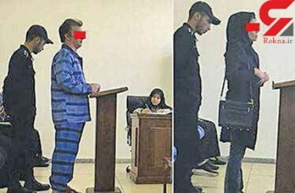
Women sentenced to 99 lashes for “illegitimate relationship”
http://bit.ly/2kXiaBH

A Young women was sentenced to 15 years of prison and 99 lashes in court on charges of complicity in murder and having an illegitimate relationship. (ROKNA state-run News Agency – Feb. 19, 2017)

Prison
Prison conditions
Prisoners to be limited in making calls to family in Zahedan Prison
http://www.balochcampaign.info/?p=10592
After widespread reports about human rights violations in Zahedan Prison, prison officials are looking to limit the prisoners’ telephone communications with outside of prison.
They have planned to change the older visiting booths to new booth systems and have provided forms in which each prisoner would only be allowed to call seven family members. (Baloch Activists Campaign – Feb. 20, 2017)

Female political prisoner journalist in dire condition in Evin Prison
https://humanrightsiniran.org/1395/35785/
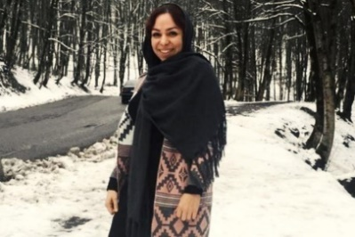
Tahereh Riahi, who is a journalist and the social editor for the state-run Borna News Agency and was arrested in Tehran on Dey 7, has suffered a number of seizures and is in poor health.
She has been under interrogations in Intellignce Dentention Center in Evin Prison since Dey 7.
She was arrested in the office of this news agency by agents of the Ministry of Intelligence on charges of “spreading propaganda against the system”. (Human Rights in Iran – Feb. 22, 2017)

Political prisoner dies in Ilam Prison due to negligence
https://humanrightsiniran.org/1395/35850/
Political prisoner Abdulnoor Sharaf Nahal who was detained in Ilam Prison, passed away after suffering a heart attack as a result of not receiving medical attention and not being transferred to hospital. Prison officials have not accepted the responsibility of the death of this prisoner. (Human Rights in Iran – Feb. 23, 2017)

Political prisoner suffering from 19 illnesses detained in Rajaie Shahr Prison
https://www.hra-news.org/2017/hranews/a-9899/
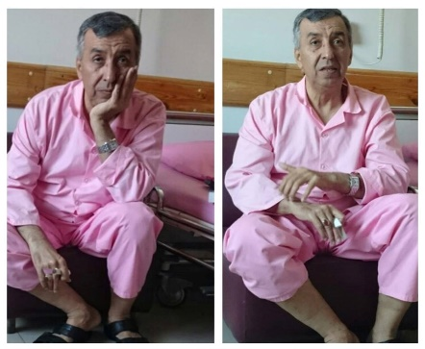
Political prisoner Asghar Ghatan is being kept in Rajaie Shahr Prison despite suffering from various illnesses and despite a forensics doctor confirming numerous times that he cannot tolerate incarceration. Mr. Ghatan is suffering from 19 various illness and takes 38 pills a day. He was detained on numerous occasions from when he was 14 because of his political activities. He was previously detained in the 70’s, 80’s, 90’s and during 2000. He has been charged with supporting the People’s Mojahedin Organization of Iran. (Human Rights Activists in Iran – Feb. 23, 2017)

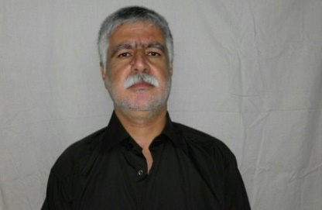
Amnesty of Mohammad Nazari wasn’t approved
http://www.kurdpa.net/farsi/idame/70003
The Iranian judiciary disagreed with the amnesty of Mohammad Nazari, one of the political prisoner who spent 23 years in prison. He also has been denied to have the right to leave. (Kurdpa - Feb. 23, 2017)

Prison sentences
Political prisoner in bad condition after 5 days of “dry” hunger strike
https://humanrightsiniran.org/1395/35595/
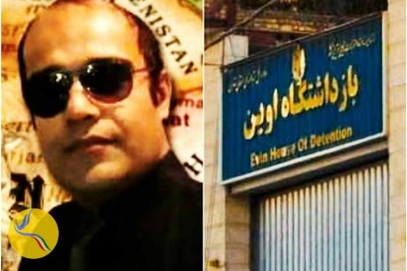
Political prisoner Vahid Sayadi Nasiri, who is detained in Tehran’s Evin Prison, is in severely bad health after five days of hunger strike, refusing to eat solid foods and liquids.
He went on a dry hunger strike in protest to being kept in Section Four in this prison. He is suffering from severe pain in his heart, kidney, liver and back, but prison officials have not heeded his request. (Human Rights in Iran – Feb. 19, 2017)

Kurd political prisoners sentenced to life in prison
http://mafnews.net/?p=14421
The life in prison sentence of political prisoner Nazmin Heidari was confirmed by the Orumieh Court of Appeal. His lawyer did not have the right to follow up his dossier or defend his client during trial proceedings.
This Kurd political prisoner from Salmas is currently serving his 4th year of prison in Salmas Prison. He has refused the charges brought against him and has filed a complaint for being tortured, mistreated and being held in solitary confinement for long periods of time during his interrogations, but has not received any responses to his complaint. (Maf News website- Feb. 21, 2017)

Sistan and Balochestan Sunni cleric banned from travel
http://www.balochcampaign.info/?p=10627
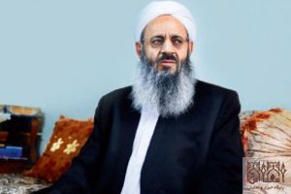
Molana Abdolhamid, Zahedan’s Sunni Friday Cleric, has been banned from internal and external travels, except travelling to Tehran. Sunni clerics living in other parts of Iran are also not allowed to travel to Sistan and Baluchestan and the Ministry of Intelligence and other security apparatuses prevent these travels. (Baloch Activists Campaign – Feb. 21, 2017)

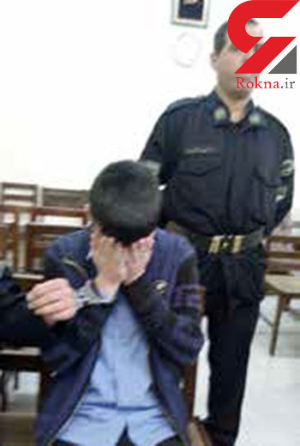
Young boy gets 30 months of prison for appropriating 20 dollars
http://bit.ly/2l59ABc
A young (underage) boy was sentenced to 30 months of prison by the Tehran Penal Court for appropriating 70,000 tomans (around 20USD) and moving drugs. The young boy said that because of his father’s economical state, he was forced into doing this. “I wanted to help my father”, he said. (ROKNA state-run News Agency – Feb. 21, 2017)

Political prisoner hospitalized for intestine cancer not released from prison
https://www.radiozamaneh.com/326497
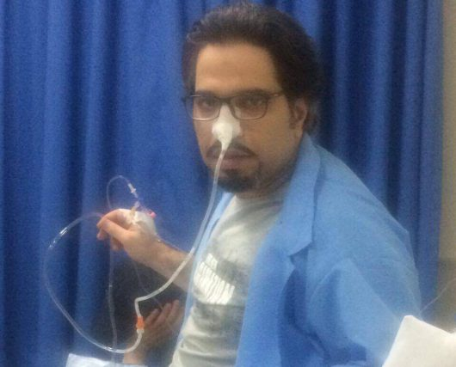
The Tehran Prosecutor prevented political prisoner Majid Mohammadi Moien, whose prison term has ended, from being released. This prisoner had gone on numerous hunger strikes during his term and is currently in hospital suffering from large intestine cancer.
Judge Moghiseye sentenced Mohammadi to four years of prison. (Radio Zamaneh – Feb. 22, 2017)

Political prisoner gets 6 year prison term
https://www.hra-news.org/2017/hranews/a-9900/
Political prisoner Hossein Danesh Payeh, who is detained in Orumieh Central Prison, was sentenced to five years of prison. The Judge has also implemented his one year suspended prison term in his sentence. (Human Rights Activists in Iran – Feb. 23, 2017)

Arbitrary arrests

Political arrests
Security forces arrest two former political prisoners
https://www.hra-news.org/2017/hranews/a-9834/
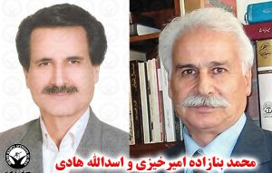
Asdollah Hadi and Mohammad Banazadeh Amirkhizi, two former political prisoners who were released in 2014 and 2015 after five years of prison, were arrested again by security forces and taken to an unknown location. Notably, Mr. Amirkhizi, 63, was arrested before this on Azar 9, 2009 after intelligence agents attacked his place of work.
Mr. Hadi who was arrested the first time during the 80’s, was sentenced to five years of prison for acting against national security and disrupting public order in 2009. (Human Rights Activists in Iran – Feb. 19, 2017

Iran jails cleric who exposed evidence of 1988 massacre of political prisoners
http://zeitoons.com/26643
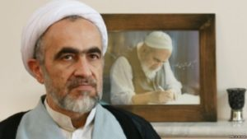
The son of Ayatollah Hossein Ali Montazeri (who was once the designated successor to Khomeini, the leader of the Islamic Republic), Ahmad Montazeri who was summoned to court today was arrested.
An informed source confirmed this and said that according to reports, Ahmad Montazeri has been transferred to Qom Prison. Ayatollah Montazeri’s website and Telegram channel published a (1988) audio tape of Ayatollah Montazeri’s meeting with Khomenie designated members of a board to oversee the condition of political prisoners. According to Montazeri’s accounts, this board issued the death sentences for thousands of political prisoners.
Ahmad Montazeri was snentenced to 21 years of prison and defrocking for three years by the Special Clerical Court in Qom. (Zeitoon state-run Website – Feb. 22, 2017)

Security forces arrest former political prisoner
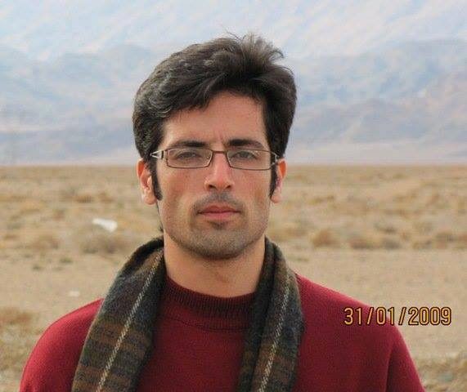
https://humanrightsiniran.org/1395/35750/
On Saturday Bahman 30, a former political prisoners Majid Asadi was arrested by security forces.
Security forces went to the home of this student activist and confiscated his personal belongings after arresting him.
Asadi was arrested before this in Ordibehesht of 1389, when he was sentenced to four years of prison. He was released on Khordad 18, 2016. (Human Rights in Iran – Feb. 22, 2017)

Social arrests
Two Erfan Halgheh followers arrested in Isfahan
https://humanrightsiniran.org/1395/35563/
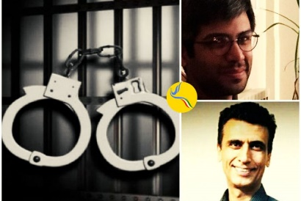
Koroush Azadi and Behrouz Nejatian, two followers of the mysticism group Erfan Halgheh, were arrested on February 18 and February 20 after being summoned to an Isfahan court. Behrouz Nejatian is currently on hunger strike in protest to his illegal arrest. (Human Rights in Iran – Feb. 21, 2017)

Labor activist transferred to Orumieh Intelligence Agency
http://mafnews.net/?p=14482
On Wednesday February 20, As’ad Molodzadeh, a labor activist residing in a village in Naghadeh, was summoned to the Intelligence Agency, where he was arrested and transferred to the Orumieh Intelligence Agency. (Maf News Website – Feb. 21, 2017)

One Kurd citizen arrested in Saqez
http://mukriannews.eu/?p=23349&lang=fa
A Kurd citizen was arrest in Saqez. He was identified as Farhad Maleki, charged with cooperate with a dissident Kurd Group. His family pursuit of judicial and security authorities, has so far been fruitless.

Basic freedom and rights abused
Trafficking children’s organs in Iran
http://www.mehrnews.com/news/3910999
The Assistance Head of the Majlis Judicial and Legal Commission said that there were weaknesses in dealing with the organ trade in Iran.
“Unfortunately, the method of donating organs is leading to people selling their body parts out of economic problems”, Yahya Kamalipour said…
“We have witnessed numerous crimes in this regard… the crimes have reached the extent where sometimes smugglers identify children, especially street children, and after kidnapping them and taking their body parts, sell and traffic the organs”, he added. (Mehr state-run news website – Feb. 23, 2017)

Iran is 8th in the world in terms of prison population
http://www.iribnews.ir/fa/news/1525499
The head of the Prison Organizations said that 13,000 people are jailed for unintentional crimes in Iran’s prisons.
“Iran is in eighth place in the world in terms of prison population”, Jahangir added. (State run website of Central News Unit – Feb. 22, 2017)

Suppressive maneuvers
Ahwaz prisoners suppressed for demanding minimum services
https://www.radiozamaneh.com/325679
A protest by Ahwaz Prison inmates to the lack of water and electricity in this prison was met with violent suppression. According to reports, at least seven prisoners were transferred to solitary cells.
Special Prison Guards attacked the 300 protesters with clubs and tear gas and destroyed their personal belongings. The attack was specifically targeted at political prisoners. (Radio Zamaneh – Feb. 18, 2017)

Feast of Fire Festival deemed as threat, security forces to crack down on festival goers
http://www.snn.ir/detail/News/587029/84
The State Security Forces spokesperson said that they were monitoring the virtual and real world on the verge of the last (Tuesday) of the (Persian Year) to deal with dangerous actions on this night. (Iranians traditionally celebrate Feast of Fire on the last Tuesday of the Persian year.)
“We have increased our monitoring around this issue from some time ago and have control on the virtual and real world and offenders will be dealt with”, he added. (Daneshjo state-run website – Feb. 21, 2017)

Noise control in detention Persians
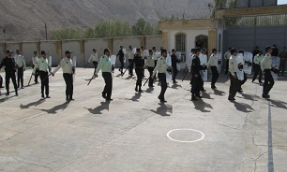
http://bit.ly/2mjAlSt
Noise control in detention Persians along with the city's police commander was held. The aim of the maneuver, was deal with any disturbance, control of the detainees as well as the skills necessary in times of crisis.
(Mizan online state-run news website - Feb. 21, 2017)

Violence against women

Iran: Young woman expelled from national team for not wearing the veil
http://www.farsnews.com/newstext.php?nn=13951130000639
Dorsa Derakhshani, member of the Iranian Women's National Chess Team and the sixth world champion in under-18 games, got expelled from the national team for not covering her hair in the Tradewise Gibraltar Chess Festival.
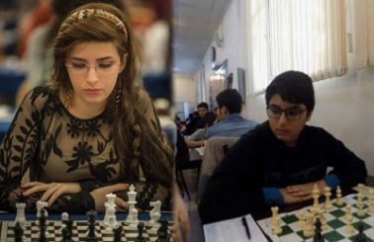
Head of Iran's Chess Federation, Mehrdad Pahlevanzadeh, said they will "seriously deal" with a sister and brother who played in the chess festival in Gibraltar because the girl did not observe the veil and the boy played with an Israeli player.
Pahlevanzadeh pointed out, "The first step in dealing with them would be to deprive them from every game that is played in Iran and in the name of Iran, and they will not have the chance to be on the national team."
Dorsa Derakhshani, 18, is presently studying in Spain and had participated in the Gibraltar games independently. Her brother, Borna, 15, had also registered in the games on his own. He played with Alexander Huzman, grandmaster from Israel. (The state-run Fars news agency – February 18, 2017)

Young female engineer commits suicide after being raped in prison
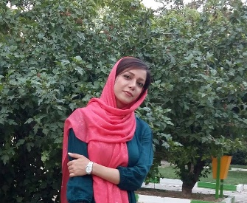
http://www.rojikurd.net/mirovayeti/24166/
Mahdis Mir Qavami, a young engineer from Kermanshah, committed suicide immediately after being released from the Kermanshah Intelligence Detention Center after an intelligence agent raped her.
Mir Qavami was summoned to this detention center on Bahman 5 and was detained there for two days. She used Aluminum phosphide, an insecticide known as rice tablets, to take her own life. (Mirovayeti Website – Feb. 22, 2017)

Girl attacked with acid in Nahavand in critical condition
https://humanrightsiniran.org/1395/35854/
The Commander of the State Security Forces in Nahavand shed light on some of the details of an acid attack in a hair salon in this town. He said that the incident took place on Thursday in a hair salon located on Azadadegan Street.
“The injured (woman) has been transferred to hospital but is reportedly in critical condition”, he added. (Human Rights in Iran – Feb. 23, 2017)

