NCRI Human Rights Center Weekly Bulletin
December 26, 2017

Systematic violations of the right to life
Executions, arbitrary killings, deaths in custody, and death sentences
Execution
Prisoner executed in Zahedan
https://www.hra-news.org/2017/hranews/a-13524/
On the morning of December 19, a prisoner was executed in Zahedan's Central Prison for murder. He has been identified as 23-year-old Yasser Salar Rashid. The prisoner was detained in Section 3 of Zahedan Central Prison for five years. (Human Rights Activists in Iran - Dec. 19, 2017)

Prisoner executed in Karaj
http://www.alef.ir/news/3960930089.html
On the morning of December 20, the retribution sentence for a person who killed a police agent was carried out in the Karaj Central Prison. The prisoner served 10 years of prison before his execution. The young man has been identified as Nima. (Alef State-run Website - Dec. 21, 2017)

Six Kurds Executed in Kermanshah Prison
http://hengaw.net/fa/?p=4694
On December 18, the execution of a Kurd prisoner identified as Mehrdad Mohammadi was carried out in Dizel Abad Prison in Kermanshah. The 33-year-old Mehrdad Mohammadi was from Kermanshah. He was sentenced to death for murder and spent seven years in prison.
The death sentence for five other Kurd citizens was also carried out on December 11 in Dizel Abad Prison. The identity of one of the executed prisoners is Kikovos Ashuri. The identities of the remaining four people is still not known. (Hengaw - Dec. 20, 2017)

Prisoner executed in Zanjan Central Prison
https://iranhr.net/fa/articles/3158/
On the morning of Tuesday, December 28, a prisoner convicted of murder was sentenced to death in Zanjan Central Prison. He was identified as Yasin Abedi from Qazvin. (Iran Human Rights Organization – Dec. 20, 2017)
At least 8 prisoners hanged in Rajaie Shahr Prison
https://iranhr.net/fa/articles/3159/
On the morning of Wednesday, December 29, at least eight prisoners were executed in Rajaie Shahr Prison in Karaj. The prisoners, who were mostly sentenced to death for murder charges, were transferred to solitary confinement in a group of ten. Four of the executed prisoners have been identified as Mustafa Chardalli, Mir Abbas Ardestani, Hamid Abdollahi and Nima Isma'ilian. According to an informed source, Hamid Abdullahi was 24 years old and has been imprisoned since he was 19. (Human Rights Organization of Iran - Dec. 20, 2017)

Arbitrary killing
Security forces fatally shoot two young Kurds in Sardasht
http://www.kurdpa.net/farsi/idame/71942
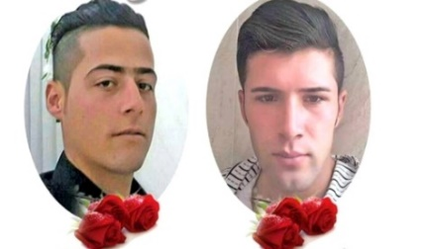
At 1 am on December 16, security forces in Bitush Village in Sardasht, targeted a group of Kurdish merchants. As a result, two young men, identified as 20-year-old Osman Ahmadi and 22-year-old Mohammad Bahrami were shot and killed. (Kurdpa - Dec. 17, 2017)

Death sentence
Women sentenced to death for adultery in Tehran
http://fararu.com/fa/news/340856
A woman was sentenced to death for adultery by the 1st Branch of the Alborz Penal Court in Alborz Province
The woman, who was confronted with undeniable documentation and could not defend herself, accepted the charges. The Judges condemned the young woman to death for adultery after reviewing her case. (Fararu State-run Website - Dec. 19, 2017)

14 prisoners taken for execution
https://iranhr.net/fa/articles/3154/
On the morning of December 16, four prisoners who were sentenced to public execution were taken to solitary confinement from Rajaie Shahr Prison’s Section 5 for their sentences to be carried out. Two of them have been identified as Moslem Mohammadi and Mohsen Kamali. They have been charged with armed robbery.
Also on December 18, 10 prisoners mostly charged with murder who have been sentenced to death, were transferred to solitary confinement to await their death sentences. Five of these prisoners have been identified as Peiman Sheikhi, Amir Abbasi, Mohammad Reza Ghera’at, Mustafa Charduli and Amir Abbas Ardestani. (Iran Human Rights - Dec. 19, 2017)

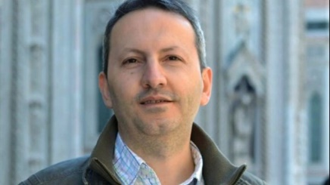
Forced confessions of death row scientist broadcasted on state-run TV
http://p.dw.com/p/2pXqK
On the evening of Sunday December 17, state-run TV broadcasted the “confessions” of detained scientist Mohammad Reza Jalali. In the video, which was produced by the Anti Espionage Department of the Ministry of Intelligence, Jalali confesses to spying for the Israeli secret service, Mossad. According to Jalali's wife, these confessions were taken from her husband after pressure was put on him. His wife, Vida Mehrania, said that her husband was threatened that their children in Sweden would be killed if he didn’t cooperate with them. She also stated that her husband had been given drugs before he was filmed. Jalali had told his wife in a telephone call that during the interview, interrogators did not allow him to respond and repeatedly cut him off. (Deutsche Welle- Dec. 18, 2017)
Link of Mohammad Reza Jalali’s forced confession:
https://www.youtube.com/watch?v=UNqMHM_KPMI

Jailed scientist says his TV confessions not reliable
http://www.bbc.com/persian/iran-42420138
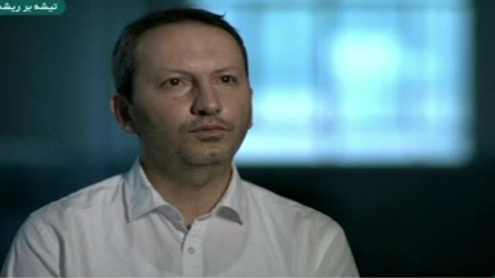
Ahmad Reza Jalali, a doctor (scientist) sentenced to death in Iran, said in an audio file attributed to him that his confessions broadcasted on state-run TV a few days ago were not reliable. In this audio file, he said that his confessions were taken under unfavorable psychological conditions and with a promise of his freedom. Those close to Jalali spoke with the Persian BBC on December 19 and confirmed the audio file saying that Mr. Jalali had recorded it in prison.
In the "Confessions" video that was broadcasted two days ago by Iranian state television, the Iranian researcher said that when he was studying and working in Europe, a person named Thomas introduced him to intelligent agents.
It was said in this documentary that Mr. Jalali provided intelligence regarding assassinated (Iranian) scientists to Mossad. (BBC - Dec. 19, 2017)

Inhumane treatment and cruel punishments
Amputation, flogging, torture and humiliation
Young man experience 3 executions
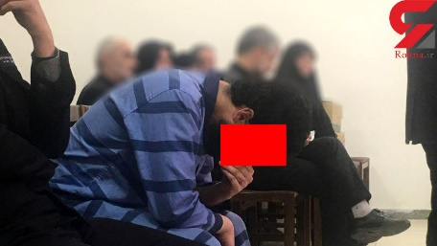
https://www.rokna.net/%D8%A8%D8%AE%D8%B4-%D9%BE%D8%B1%D9%88%D9%86%D8%AF%D9%87-3/338008-%D8%A7%DB%8C%D9%86-%D8%A7%D8%B9%D8%AF%D8%A7%D9%85%DB%8C-%D8%A8%D8%A7%D8%B1-%D9%BE%D8%A7%DB%8C-%DA%86%D9%88%D8%A8%D9%87-%D8%AF%D8%A7%D8%B1-%D8%B1%D9%81%D8%AA-%D8%A7%D8%B9%D8%AF%D8%A7%D9%85-%D9%86%D8%B4%D8%AF-%D8%B9%DA%A9%D8%B3
A young man who was accused of murder following family disputes was taken to the gallows three times. He has been identified as 26-year-old Nader. Nader, who was tried by the 71st Branch of the Tehran Penal Court, was sentenced to retribution upon a request by the victim’s family. His death sentence was ultimately cancelled. (ROKNA State-run Website - Dec. 18, 2017)

Jailed activist says no one held responsible for his torture
https://humanrightsiniran.com/1396/52614/
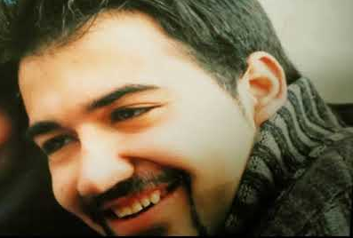
Political prisoner Soheil Arabi wrote a letter from prison about the tortures and pressures he was subjected to. His letter reads in parts:
“I was kept in solitary confinement until January 2013 in the 2A Sarallah Revolutionary Guards Corps Detention Center. During the 58 days of solitary confinement, I was repeatedly tortured both psychologically and physically. I was hanged by my feet, subjected to mock execution, and threatened with the rape of my wife. All my confessions were made under torture...I was severely beaten upon my arrival at 2A...
This November when I was beaten and threatened to death, instead of punishing the perpetrators, I was detained for 28 days in quarantine in Evin Prison deprived of phone calls and visits and was beaten by other prisoners on two occasions. (Human Rights in Iran - Dec. 16, 2017)

Fruit vendors beaten by police in Malayer
https://www.isna.ir/news/96092715338
On the afternoon of December 17, Malayer municipality agents in Azadi Square, beat a number of fruit vendors in Azadi Square. The vendors were injured and taken to hospital. "My brothers and I own several shops in Azadi Square in Malayer”, one of the vendors explained. “Yesterday morning, while I was resting, I noticed that the municipality agents were gathering our fruits”. He said that after protesting, agents clashed with them and beat them with batons. "In the clash, my brother’s leg and head were injured. The baton marks are evident on his body and mine”, he added. (ISNA state-run News Agency - Dec. 18, 2017)

Kurd civil rights activists sentenced to flogging
http://www.kurdpa.net/farsi/idame/71972
Three Kurds were sentenced to flogging and a fine for participating in a gatherings to support the referendum on Kurdish independence and disturbing public order. Menareh Mullaveiseh and Ayoub Javanpour were each sentenced to 50 lashes and one million and 800 thousand tomans. Student activist Zamaneh Zivouie was also sentenced to 50 lashes and a fine of one million and 800 thousand tomans (about 500 dollars). (Kurdpa - Dec. 21, 2017)

Prison
Prison conditions
New charges brought against political prisoners in Rajaie Shahr Prison
https://humanrightsiniran.com/1396/52647/
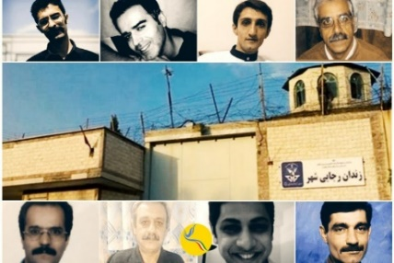
The condition of political prisoners in Rajaie Shahr Prison in Karaj has not improved since their transfer to a new section four months ago. Authorities have also brought new charges against some of these political prisoners to put more pressure on them.
New lawsuits were filed against eight political prisoners after they protested the change of their hall. These prisoners have been identified as Saied Masouri, Reza Akbari Monfared, Saied Shirzad, Hassan Sadeghi, Amir Ghaziani, Jafar Eghdami, Abolghasem Fouladvand and Ibrahim Firouzi, who in the new case, have been charged with "insulting the leader", "chanting slogans against government officials" and "disturbing prison order". (Human Rights in Iran - Dec. 18, 2017)

Political prisoner mistreated in hospital
https://www.hra-news.org/2017/hranews/a-13536/
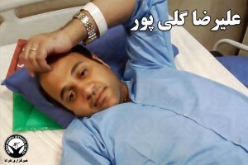
Political Prison Alireza Golipour, who is detained in Evin Prison and had previously gone on hunger strike in protest to the way his case was being handled, was taken to hospital last Thursday due to his physical weakness and effects of the hunger strike. The prisoner was kept with handcuffs and foot shackles during his 8 days in the hospital.
Golipour's lawyer said that the prisoner had been mistreated by an agent. Mr. Golipour fell down the hospital stairs after the agent attacked him. Alireza Golipour is a member of the National Elite Foundation and a Ph.D. student in electrical engineering in Germany. He has been charged with security offenses and has been detained in Evin Prison since 2012. (Human Rights Activists in Iran - Dec. 20, 2017)

Prison sentences
Baha’i woman arrested to serve 5-year prison term
https://www.hra-news.org/2017/hranews/a-13512/?tg_rhash=22a41dd9689763
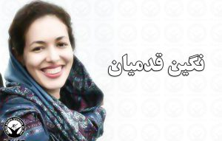
Neghin Ghadamian, a Baha'i woman living in Tehran, who was sentenced to 5 years of prison on charges of collaborating with the Baha’i Virtual University, was arrested on Saturday December 16 at the airport and was transferred to Evin Prison to serve her sentence. (Human Rights Activists in Iran - Dec. 18, 2017)

Arbitrary arrests
Social arrests
Telegram channel admin arrested in Gorgan
http://www.ilna.ir/%D8%A8%D8%AE%D8%B4-%D8%A7%D8%B3%D8%AA%D8%A7%D9%86-%D9%87%D8%A7-15/572114-%D8%A8%D8%A7%D8%B2%D8%AF%D8%A7%D8%B4%D8%AA-%D9%85%D8%AF%DB%8C%D8%B1-%DA%A9%D8%A7%D9%86%D8%A7%D9%84-%D9%85%D8%B3%D8%AA%D9%87%D8%AC%D9%86-%D8%AA%D9%84%DA%AF%D8%B1%D8%A7%D9%85%DB%8C-%D8%AF%D8%B1-%DA%AF%D8%B1%DA%AF%D8%A7%D9%86-%D8%A7%D8%AE%D8%A7%D8%B0%DB%8C-%D8%A7%D9%86%D8%AA%D8%B4%D8%A7%D8%B1-%D8%AA%D8%B5%D8%A7%D9%88%DB%8C%D8%B1-%DB%8C%DA%A9-%D8%B2%D9%86-%D8%AF%D8%B1-%DA%AF%D8%B1%D9%88%D9%87-%D9%87%D8%A7%DB%8C-%D8%AA%D9%84%DA%AF%D8%B1%D8%A7%D9%85%DB%8C
Gorgan Prosecutor Mostafa Haghi said that the administrator of 110 Telegram channels was arrested in this city.
“This person made another group every time his channel was filtered”, he added.
“He was arrested and imprisoned with the cooperation of the Cyber Police after a case was filed for him in the Gorgan court”, the Gorgan Prosecutor added. (ILNA state-run News Agency - Dec. 19, 2017)

Telegram channel admin arrested in Gonabad
https://www.tasnimnews.com/fa/news/1396/09/28/1605595
The Gonabad Police Commander said that the Cyber Police in this town identified and arrested the administrator of a Telegram channel.
“Cyber Police experts made observations in cyberspace and identified a channel with more than 283 members. The channel was active in publishing content and persuading people to resort to immoral conduct. Cyber Police experts identified the administrator of the channel who is a young man by the name of Abolfazl, and arrested him after judicial coordination”, Ali-Akbar Kiani added. (Government News Agency - Dec. 19, 2017)

Internet activists arrested in Tehran and Shahre Rey
http://www.ilna.ir/%D8%A8%D8%AE%D8%B4-%D8%A7%D8%AC%D8%AA%D9%85%D8%A7%D8%B9%DB%8C-5/569694-%D8%AF%D8%B3%D8%AA%DA%AF%DB%8C%D8%B1%DB%8C-%D8%B9%D8%A7%D9%85%D9%84%D8%A7%D9%86-%D8%A7%DB%8C%D8%AC%D8%A7%D8%AF-%D8%B1%D8%B9%D8%A8-%D9%88%D8%AD%D8%B4%D8%AA-%D8%AF%D8%B1-%D9%81%D8%B6%D8%A7%DB%8C-%D9%85%D8%AC%D8%A7%D8%B2%DB%8C
The head of the Tehran Police Hossein Rahimi said that an element of cyberspace was arrested in Nezam Abad.
“Following the publishing of profanity by a number of troublemakers against each other which created an atmosphere of fear in cyberspace, police were tasked with the issue after judicial coordination”, he added.
“In the ensuing technical and intelligence measures, one of the main culprits of this issue was identified and arrested in Nezam Abad”.
Rahimi said that three other elements were also identified and arrested in Shahre Rey and Khomeini airport. (ILNA state-run News Agency - Dec. 13, 2017)

Internet activists arrested in Golestan Province
https://www.tasnimnews.com/fa/news/1396/09/29/1607012
The head of the Golestan Cyber Police said that a person who published lies against a Golestan official was arrested.
“The legal representative of one of the organizations said that an unknown person was publishing lies to blacken the image of the CEO of the organization. After initial investigations, it was found that certain people had launched a channel on one of the social networks and were uploading the cited content”, Vahid Sahebkaran said.
“As a result of the technical and intelligence measures of the province’s Cyber Police, two of the suspects were identified and their computers and telecommunications equipment were confiscated. They were both taken to prison”, he added. (Tasnim state-run News Agency - Dec. 20, 2017)

Two people arrested for posting “immoral content” on social media
http://donya-e-eqtesad.com/%D8%A8%D8%AE%D8%B4-%D8%B3%D8%A7%DB%8C%D8%AA-%D8%AE%D9%88%D8%A7%D9%86-62/3329669-%D8%B9%D8%A7%D9%85%D9%84%D8%A7%D9%86-%D8%B1%D8%A7%D9%87-%D8%A7%D9%86%D8%AF%D8%A7%D8%B2%DB%8C-%DA%A9%D8%A7%D9%86%D8%A7%D9%84-%D8%BA%DB%8C%D8%B1%D8%A7%D8%AE%D9%84%D8%A7%D9%82%DB%8C-%D8%AF%D8%B1-%D9%85%DB%8C%D8%A8%D8%AF-%D8%AF%D8%B3%D8%AA%DA%AF%DB%8C%D8%B1-%D8%B4%D8%AF%D9%86%D8%AF
The Commander of the Meibod State Security Forces said that two people who were running an immoral channel on social media were identified and arrested. “These people had launched a number of Telegram channels and uploaded vulgar images. They were arrested and handed over to court”, Mohammad Taher Moussavi said. (Donyaye Eghtesad state-run Website - Dec. 20, 2017)

Qom Cyber Police crackdown on internet users
http://qom.farsnews.com/news/13960929001817
The Commander of the Qom State Security Forces said that 87% of cybercrimes were discovered by the Qom Cyber Police this year.
“In Qom province, from the quantitative point of view, and in terms of monitoring information and dealing with criminals in cyberspace, good measures have been taken to the extent that in the last eight months, the rate of crime detection in the field of cyberspace reached 87% which indicates the efforts and effectiveness of the Qom police in this area”, Kazem Mojtabi said. (Fars state-run News Agency - Dec. 20, 2017)

19 labor activists summoned and interrogated in Sanandaj
https://www.hra-news.org/2017/hranews/a-13523/
Over the past two weeks, at least 19 labor activists in Sanandaj were questioned by the intelligence agency. The reason for the interrogation of some of them was their activities for worker rights, while others were interrogated in connection to Nowruz celebrations in Sanandaj.
They have been identified as Shadman Bani Bashar, Obeid Khaleghi, Haidar Akhteh, Massoud Mohammadi, Akbar Gavili, Ali Abdollahi, Ahmad Azizi, Jamal Yousefi, Ahmad Ghamari, Mozaffar Salehnia, Farhad Chetani, Habib Chetani, Lotfollah Ahmadi, Ahmad Karbaschi, Khaled Hosseini, Ghaleb Hosseini, Sharif Sa'edpanah, Afshin Adab and Habibullah Karimi. The activists were interrogated in the Pardis Hall in Sanandaj. (Human Rights Activists in Iran - Dec. 19, 2017)
Basic freedom and rights abused
Bassij forces launch new internet crackdown
https://www.mehrnews.com/news/4175300
The Deputy Commander of the Khorasan Razavi Revolutionary Guards Corps said that the Bassij had a specific, special and important mission inside the country.
"One of the arenas and instruments that both the enemy and we use in this cultural campaign is cyberspace", said Mojtaba Ghaforpour.
“If we do not have an intelligent presence in cyberspace, we will definitely be hurt because today, cyberspace has a direct impact on the reality of the community and individuals".
"In line with this, last year, the Bassij Organization launched a campaign called Bassij Prominence 1, and this year, the Bassij Prominence 2 exercise will be carried out from December 18 December 21 in Khorasan Razavi by all Bassij forces and commanders", he added. (ISNA state-run News Agency - Dec. 18, 2017)

Telegram CEO says 40 million Iranians have Telegram accounts
http://gilkhabar.ir/328129/%D9%BE%D8%A7%D9%88%D9%84-%D8%AF%D9%88%D8%B1%D9%88%D9%81-%D8%AA%D8%B9%D8%AF%D8%A7%D8%AF-%DA%A9%D8%A7%D8%B1%D8%A8%D8%B1%D8%A7%D9%86-%D8%A7%DB%8C%D8%B1%D8%A7%D9%86%DB%8C-%D8%AA%D9%84%DA%AF%D8%B1%D8%A7/
http://itiran.com/node/74146
The CEO of Telegraph posted a message on his channel citing Telegram Voice and its blockage in a number of countries. Pavel Durov said that the social network had 180 million users, of whom only 40 million lived in Iran. He said that Telegram Voice had been blocked in Iran. According to Durov, 500,000 people join Telegram every day. Telegram currently accounts for 40 percent of Iran's Internet traffic and has 500,000 Persian channels that freely send and receive all kinds of content. (IT Iran state-run Website, Gil Khabar state-run Website - Dec. 13, 2017)

Tehran police storms mixed gender hairdressing class, arrests stylists
http://www.yjc.ir/fa/news/6365470
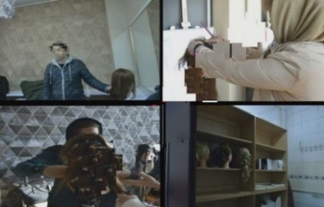
The head of the Security Police in the Greater Tehran District said that a number of young women and men were arrested in a mixed gender hairdressing class.
"Following the news of mixed gender classes for women's hair styles by foreign male trainers and the recruiting of women hairdressers to go abroad, the police were tasked with identifying the classes”, Zolfaghar Barfar said.
“After the issue became clear, agents went to the scene and arrested a number of men and women who were working on wigs and human models in the class”, he added. (YJC state-run Website - Dec. 18, 2017)

Iranian filmmaker banned from leaving Iran says he is waiting for interrogations
http://www.bbc.com/persian/arts-42400404
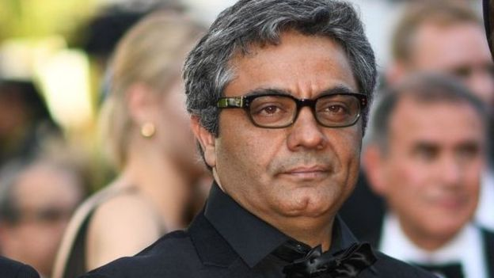
Iranian filmmaker Mohammad Rasullof, who has been banned from leaving Iran, said security officials had informed him that he should wait for further interrogations. Mr. Rasullof said he faces two charges of gathering and conspiring against national security and spreading propaganda against the government. Mr. Rasullof was sentenced to six years of prison in 2010 for similar charges. The reason for those charges was a documentary he made on protests following the 2009 presidential election. (BBB - Dec. 18, 2017)

Gender segregation in Tehran artists’ cemetery
https://www.isna.ir/news/96092513699
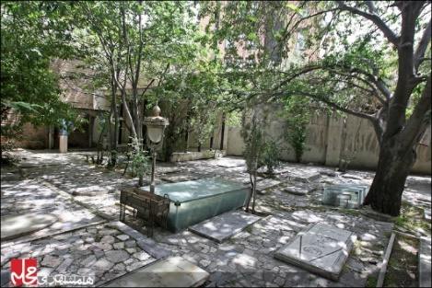
Despite the fact that Zahir al-Dawlah Cemetery is not even open to the public for people to pay their respects, officials have enforced the illegal rule of gender segregation in the cemetery... What (do they think) people do in this graveyard where artists are buried, that women should be separated from men? The gender segregation in the Zahir al-Dawlah Cemetery is a clear insult to the Iranian people. (ISNA state-run News Agency - Dec. 16, 2017)

Interior Minister bans job of carrying goods via border in Iran
http://www.eghtesadnews.com/%D8%A8%D8%AE%D8%B4-%D8%A7%D9%82%D8%AA%D8%B5%D8%A7%D8%AF-%D8%AF%D8%B1-%D8%B1%D8%B3%D8%A7%D9%86%D9%87-%D9%87%D8%A7-67/194293-%DA%A9%D9%88%D9%84%D8%A8%D8%B1%DB%8C-%D8%A7%D8%B2-%D8%A7%D9%85%D8%B1%D9%88%D8%B2-%D9%85%D9%85%D9%86%D9%88%D8%B9-%D8%B4%D8%AF
https://www.radiozamaneh.com/372543
Interior Minister Abdulreza Rahmanifazli said that according to the government's decision, porter work was banned.“Nobody has the right to do (border) porter work and the borders will be closed”, he added saying that porter work was against human dignity and Iranian citizenship rights. (Government News website, Radio Zamaneh - Dec. 26, 1396)
There are 75,000 porters in Iran, 20,000 of whom live in Sardasht and Piranshahr. Most porter workers are poverty stricken people who are forced into this dangerous job to make a living.

Kurd aid worker commits suicide after seeing condition of earthquake stricken people
http://www.kurdpa.net/farsi/idame/71949
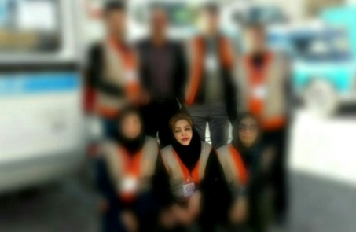
On Friday, December 15, a Kurdish woman activist, Roghiye Saeedi, committed suicide and died after two days in hospital. Mental pressure and poverty were the reasons for her suicide. According to a close acquaintance of Roghiye Saeedi, she was a medic and aid worker who was one of the first on the scene to help earthquake victims in Kermanshah, and the poor condition of the earthquake stricken people left a negative effect on her mental state. (Kurdpa - Dec. 18, 2017)

More than 18,000 unemployed people have university degrees in Yazd
http://www.farsnews.com/newstext.php?nn=13960925001676
The Deputy Director of Statistics and Information Management and Planning Organization of Yazd Province said that according to the unemployment statistics in 2017, in Yazd province 18,205 people with higher education were unemployed.
“From a total of 541,774 who are economically inactive (in Iran), 105,666 have higher education and 436,098 people have other kinds of education”, Fakhroddin said. “Out of the total population of educated inactive people, 39,335 are men while 66,331 are women, and in the province, approximately 63 percent of educated women are unemployed”, he added. (Fars state-run News Agency - Dec. 16, 2017)

80% of people in Sistan and Baluchistan under poverty line
http://www.ilna.ir/%D8%A8%D8%AE%D8%B4-%D8%A7%D8%B3%D8%AA%D8%A7%D9%86-%D9%87%D8%A7-15/570556-%D8%AF%D8%B1%D8%B5%D8%AF-%D9%85%D8%B1%D8%AF%D9%85-%D8%B3%DB%8C%D8%B3%D8%AA%D8%A7%D9%86-%D8%A8%D9%84%D9%88%DA%86%D8%B3%D8%AA%D8%A7%D9%86-%D8%B2%DB%8C%D8%B1%D8%AE%D8%B7-%D9%81%D9%82%D8%B1-%D9%87%D8%B3%D8%AA%D9%86%D8%AF-%DA%A9%D8%A7%D8%B1%DB%8C-%D8%A7%D8%B2-%D9%85%D8%AC%D9%84%D8%B3-%D8%B3%D8%A7%D8%AE%D8%AA%D9%87-%D9%86%DB%8C%D8%B3%D8%AA
Hossein Ali Shahriari, the Zahedan representative in Majlis, said that about 80 percent of people were under the poverty line in the province of Sistan and Baluchistan.
"Those living in Tehran must have an income equivalent to four million tomans (112 dollars). Those who do not have this income in Tehran are definitely under the line of poverty”, Shahriari said.
"Three percent of Iranian families are also under the poverty line because of the cost of medical treatment", he said. (ILNA state –run News Agency - Dec. 15, 2017)

281 work related deaths in 8 months in Tehran
http://www.iribnews.ir/fa/news/1951296
The Director General of the Tehran Medical Examination said that 281 deaths due to work accidents in the first eight months of this (Persian) year were referred to Medical Examination Centers in Tehran province.
“This figure has increased by 18% compared to the same period last year, when the number of deaths due to work accidents was 238”, Dr. Masoud Qadi Pasha added.
He said that out of the total number of deaths due to work incidents in eight months, 279 were men and 2 were women. (Seda and Sima state-run News Agency – Dec. 18, 2017)

Air pollution crisis leads to 200% increase in heart attacks
http://www.farsnews.com/13960928001406
The intensity of air pollution in the past few days, in addition to a heavy flow of people going to hospital emergency rooms, has doubled the rate of heart attacks. The country's largest cities were heavily polluted last week, and schools were shut down in many of these cities. In cities like Tehran and Tabriz this has affected people's physical condition.
Mojtaba Khaledi, a spokesperson for the emergency department, said that there was a 10% increase in emergency calls today compared to yesterday and a 20% increase of calls compared to last week.
“The rate of heart attacks in pre-hospital emergency services has doubled over the past week as well”, he added. (Fars state-run News Agency - Dec. 19, 2017)

Orumieh Lake decreases by 323 km
https://www.isna.ir/news/96092916706
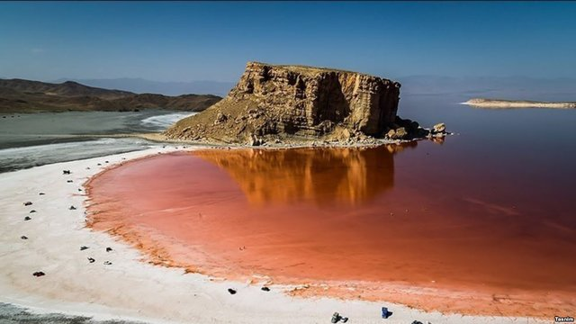
The Director of the provincial headquarters of the Urumieh Lake Revival Directorate in West Azerbaijan said that this year, there was a 323 km decrease of the size of Lake Urumieh.
Last year, at the same time, the water level of Lake Urumieh was 1270.55 meters, which indicates a 27cm decrease in water level compared to last year”, Farhad Sarkhosh added. (ISNA state-run News Agency - Dec. 20, 2017)
Religious and ethnic minorities
Guardian Council rejects Majlis bill on minorities
http://www.farsnews.com/13960927001852
In a letter to the Majlis Spokesperson Ali Larijani, the Guardian Council rejected a Majlis resolution on the membership of religious minorities in city and village councils. The letter was signed by the Deputy Secretary of the Guardian Council, Mohammad Reza Alizadeh. (Fars state-run News Agency - Dec. 18, 2017)

Young Baha’i man sentenced to two years of prison
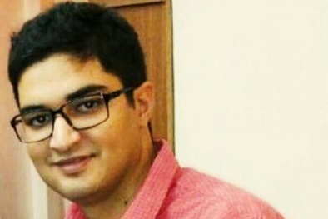
https://humanrightsiniran.com/1396/52702/
The 2nd Branch of the Revolutionary Court issued a two-year imprisonment sentence for Yahshar Rezvani, a Baha'i citizen living in Tehran. He was sentenced to two years of prison on charges of "membership in the Baha'i organization." (Human Rights in Iran - Dec. 21, 2017)

Baha’i girl expelled from university in Kashan
http://bahaicamp.com/paria-foroghi-ekhraj/
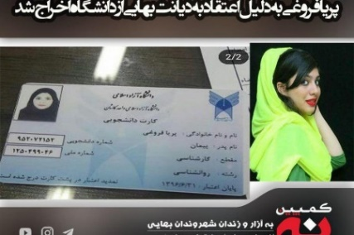
Paria Forughi, a third year student of psychology, was expelled from the Azad University of Kashan because of her Baha’i faith.
"I was giving an exam when I was summoned to the office of the head of the university, where I realized (that I had been expelled)," the Baha'i citizen said.
According to the secret decree of the Supreme Council of the Islamic Revolution's Cultural Revolution, Baha'is are to be deprived of university education, in addition to the denial of employment in public places. (Baha’is Campaign - Dec. 20, 2017)

Violence against women

No women in Qom managerial jobs
http://www.asriran.com/fa/news/579792
Fatima Ahmadi, a member of the Qom City Council said that despite the high numbers of educated women in Qom, there was not even one woman in executive managerial jobs in the province. (Asre Iran state-run Website - Dec. 18, 2017)

Close to 1,500 girls under 14 years of age married in one year in Zanjan
http://www.irna.ir/fa/News/82765551
The Director General for Women and Family Affairs at the Zanjan Governorate said that in the past year, 1,485 marriages of girls under the age of 14 were registered in this province, 47 of which resulted in divorce.
"In the first six months of this (Persian) year, 5,040 marriages were registered in Zanjan province, 19% of which resulted in divorce", Mahrokh Bolori added. (IRNA state-run News Agency - Dec. 16, 2017)

